Register Number: _____________________

DHANALAKSHMI SRINIVASAN ENGINEERING COLLEGE, PERAMBALUR – 621 212
(AUTONOMOUS)

DEPARTMENT OF AERONAUTICAL ENGINEERING

U20AE502/ Aircraft Structures
ASSESSMENT TEST – I
Year /Semester: III / V Date:
Duration: 90 minitues Total Marks: 60
Part A: 10 X 2 = 20 Marks
Answer all the questions
1 | Differentiate symmetric & unsymmetrical bending? | 2 | CO1 | BTL2
2 | What is monocoque structure? | 2 | CO1 | BTL2
3 | What is semimonocoque structure? | 2 | CO1 | BTL2
4 | Define Principal axis and Neutral axis. | 2 | CO1 | BTL2
5 | Define Hooke’s law? | 2 | CO1 | BTL2
6 | Write the assumptions of plate theory. | 2 | CO2 | BTL2
7 | Define shear stress? | 2 | CO2 | BTL2
8 | Define shear flow? | 2 | CO2 | BTL2
9 | How does a laminate differ from a lamina? | 2 | CO2 | BTL2
10 | Define shear center? | 2 | CO2 | BTL2

Part B: 2 X 13=26; 1X14=14=40 Marks

Answer all the questions
11 | a | i | Find the bending stress at location A and B of I-section and calculate the angle. A 10 kN·m bending moment acts at an angle of 30° as shown in the figure.  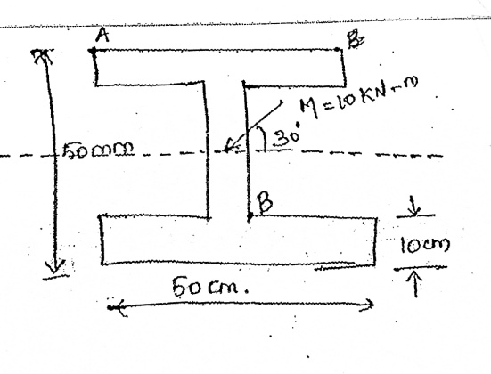 | 13 | CO1 | BTL3
11 | or
11 | b | ii | Find the bending stress at the corner points of Z section with flanges 10x3cm and web 15x3cm subjected to moments Mx=10kNm and My=5kNm. Also, calculate the neutral axis.  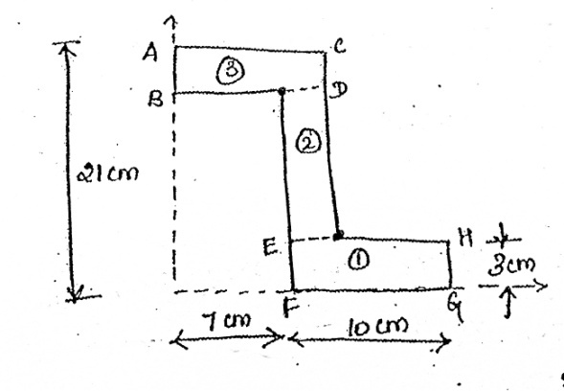 | 13 | CO1 | BTL3
12 | a | i | Find the normal stress distribution of a thin-walled Z-section, thickness t, height of the web h, and flange width h/2, when it's subjected to a bending moment Mx.  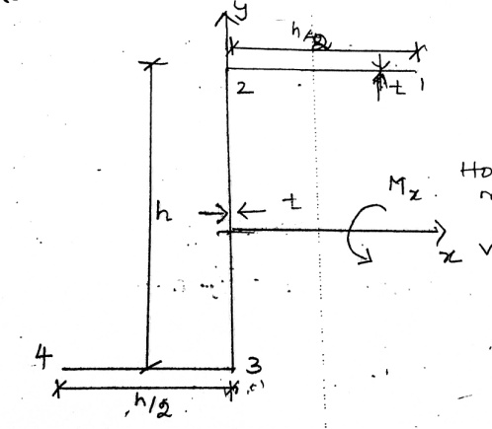 | 13 | CO1 | BTL4
12 | or
12 | b | ii | A bending moment of 3000 Nm is applied to the purlin in a plane at an angle 30° to vertical axis. If the sense of bending moment is such that component Mx and My both produces tension in positive XY quadrant, calculate the maximum direct stress in purlin stating clearly at which point it acts.  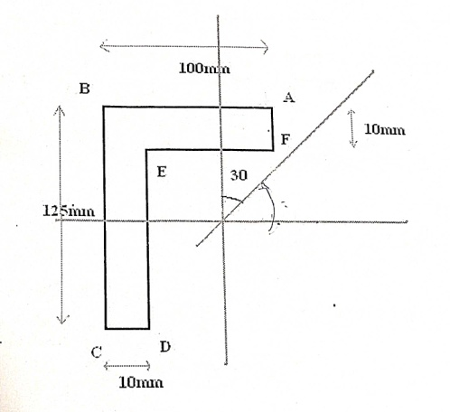 | 13 | CO1 | BTL4
13 | a | i | Derive an expression for determining the shear stress of an open section beam. | 14 | CO2 | BTL3
13 | or
13 | b | ii | Determine the shear flow distribution in the thin-walled Z section as shown in figure, due to a shear load Sy applied through the shear center of the section.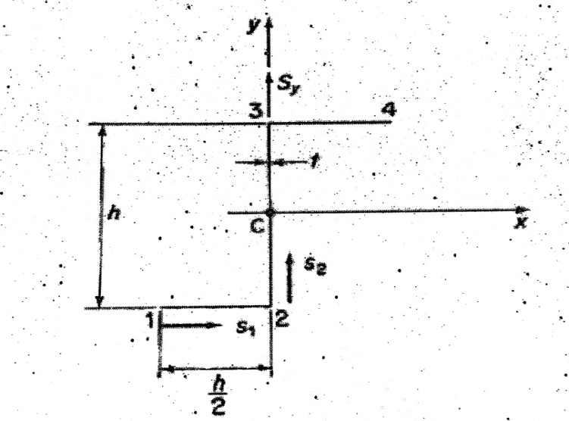 | 14 | CO2 | BTL4

Prepared by Verified by

